To Whom It May Concern:

When running the R Scripts in this folder, it is highly recommended that you **run them locally**. It will run a lot faster because data will not need to transfer over the network. To do that, you can just copy and paste the entire folder containing the R script you want to use into your C: drive. **OR USE THE SHELL - it can still run quickly in the network drive (see Ting-Fang)**

**Note: It will still work if you just change the directories directly. It just might be slower.**

I usually put mine in **Local Disk (C:)**. The directory for mine would be: “C:\Users\ttu\Documents” or “C:\Users\ttu\Desktop” in the computer. In R script the “\” need to be changed to “/” because R uses “\” to mark special characters. Thus, the **directory used in R will become “C:/Users/ttu/Documents” or “C:/Users/ttu/Desktop”**.

Your computer will likely have a “fake” My Documents and Desktop folder. Do not be fooled by these. If you try to use the directories for that it will read “W:\Backup\Documents” or just “Desktop”. Sometimes this will cause errors when you are changing the directories.

**TL;DR version**: **DO NOT** copy the folders in Travis_Final_R_Scripts into the places boxed in red**. Copy them into the green and blue boxes and get the directories from the blue box**.

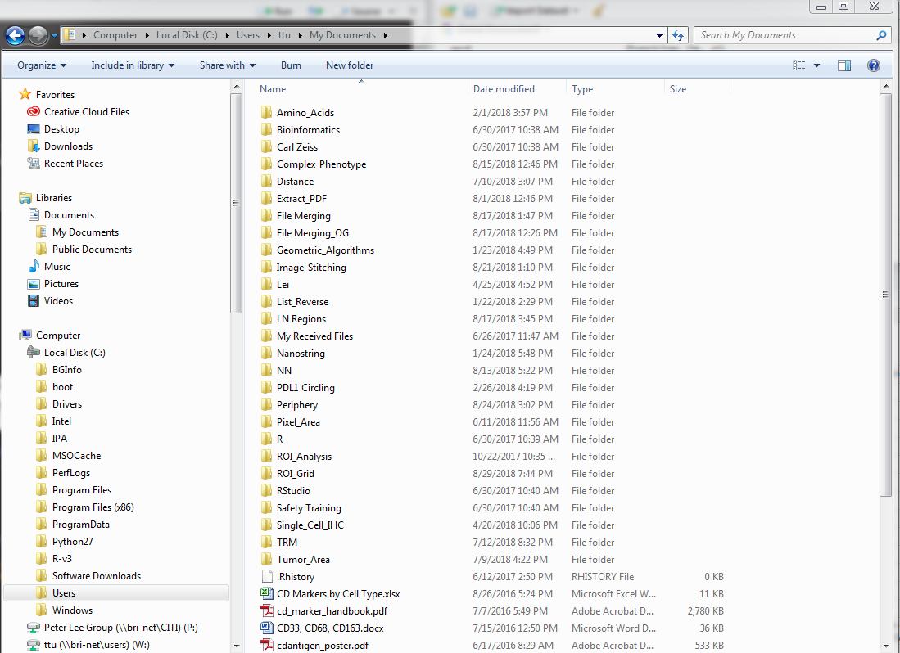

Sincerely:

The R Scripts of Travis’s Past (RIP June 2016- September 2018)